Maintenance plan

Here is maintenance plan, which reports how much will cost to maintain “Xaria” for next year.

We need five parts to estimate the cost, which are cost of hiring a developer, annual fees for server, annual fee for platform, and fees for promotion.

First, it is recruiting a perfect-well developer. Here is what I found for hiring a senior software developer.

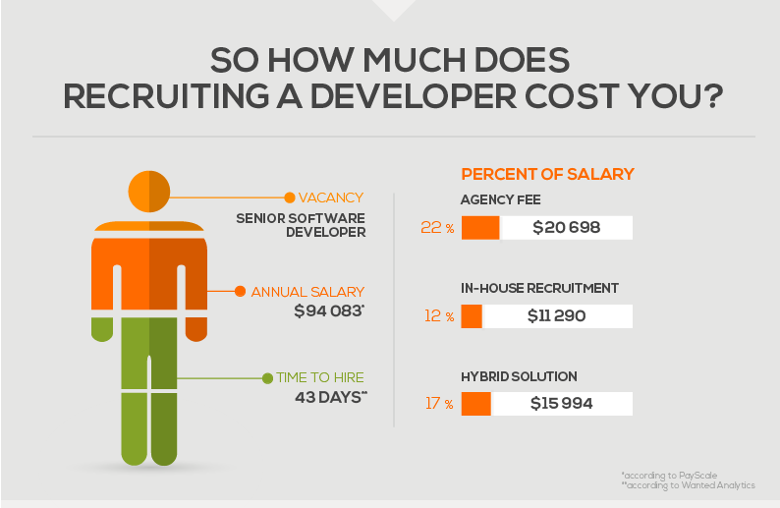

Source: https://devskiller.com/true-cost-of-recruiting-a-developer-infographic/

The cost of hiring a developer is around 94,000 dollars per year.

Next, it is the annual cost for server. Here is what I found from some rent server websites.

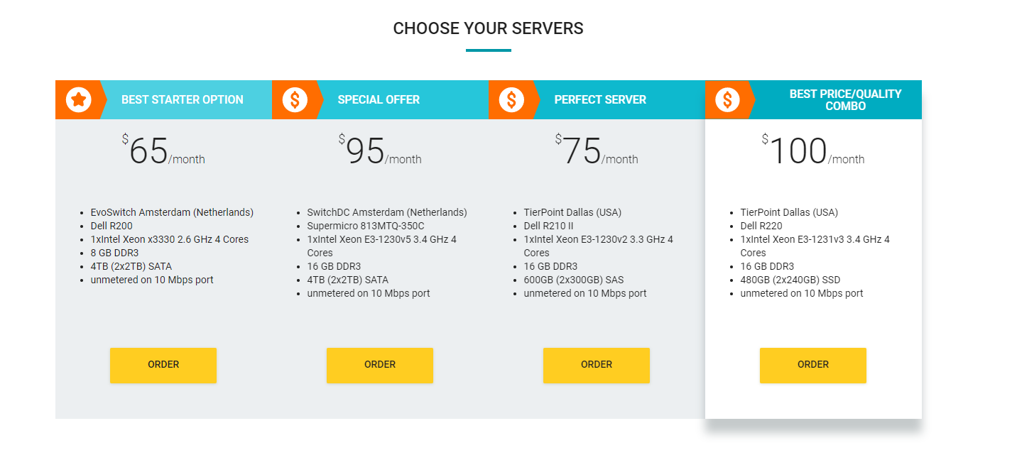

inxyhost.com



www.24shells.net

So, the cost of renting a medium type server is around 100 dollars per month, which is 12,000 dollars per year.

Next, it is the cost for annual fee for platform. Here is what I found for putting an app to apple store.

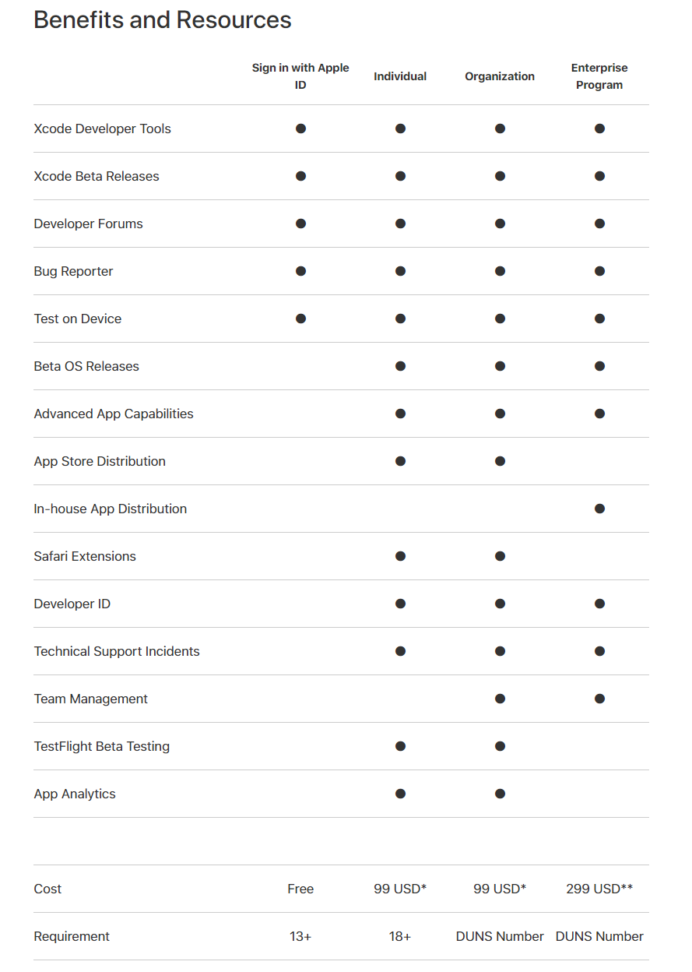

Apple Store

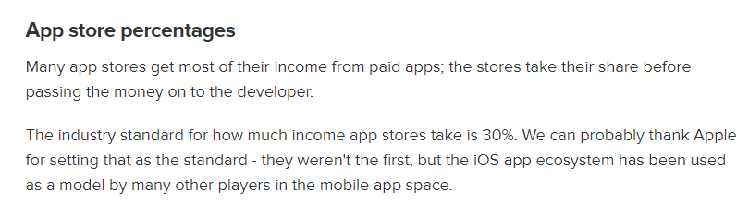

Source:https://www.techrepublic.com/blog/software-engineer/app-store-fees-percentages-and-payouts-what-developers-need-to-know/

Therefore, the cost for annual fee for platform is 100 dollars plus 30% income.

The last one, it is the cost for promotion. Here is two picture I want to show.

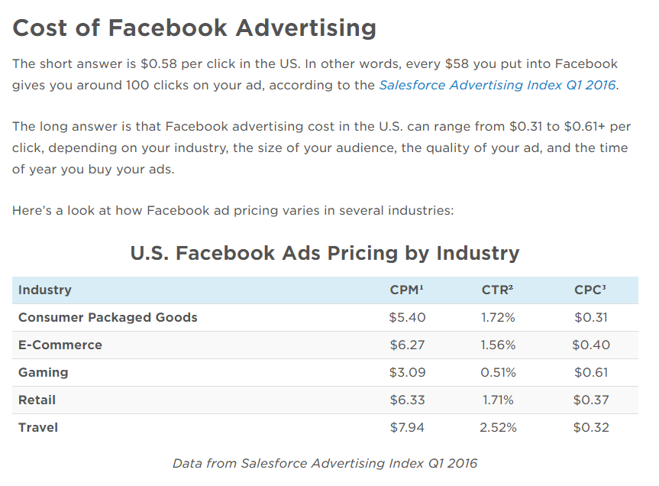

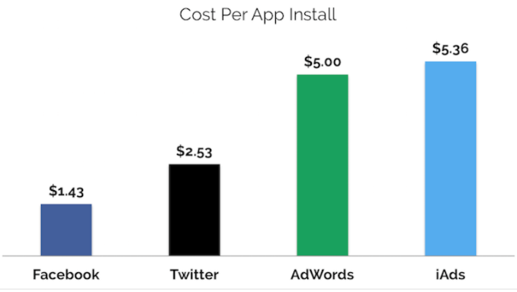

It really cost so much for promoting apps.

So, in total it will cost us 106,100 dollars for one year maintain, and also it is depends on how many users we have.